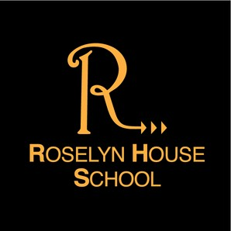
AUTUMN TERM 1

NEWSLETTER

2025
school news

Welcome back...
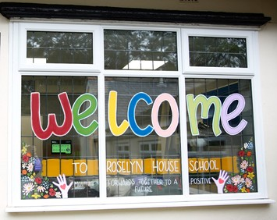
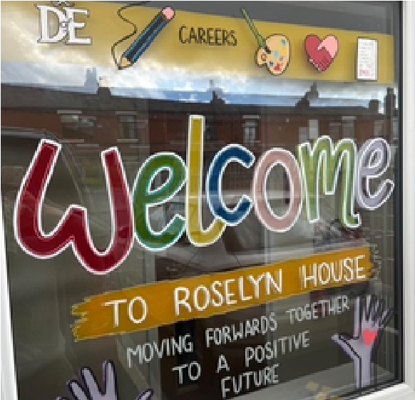
We welcomed everyone back in September after what we hope was a relaxing and enjoyable summer break. It has been wonderful to see our school community return refreshed, re-energised and ready for another exciting year of learning and growth.
A particularly warm welcome goes out to our new cohort of KS3, KS4 & KS5 students who have joined us this term. They have settled in brilliantly, already becoming valued members of our school community. It has been lovely to see new friendships forming, confident smiles appearing in classrooms, and a real sense of enthusiasm throughout the school.
This term promises to be full of opportunities, from new projects and enrichment activities to trips and events that will help our students develop their skills, confidence and curiosity. Our dedicated staff are looking forward to supporting every pupil as they continue their journey with us, celebrating achievements big and small along the way.
We’re so excited for the months ahead and can’t wait to see all that this new academic year will bring — Mr Birkenhead, Headteacher.
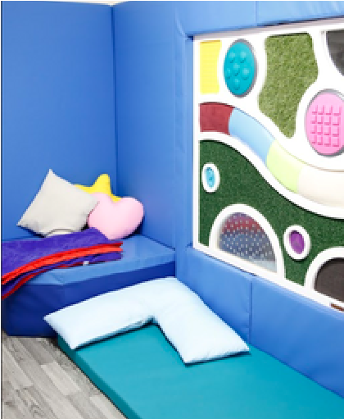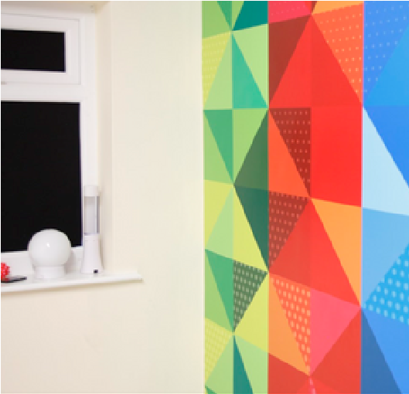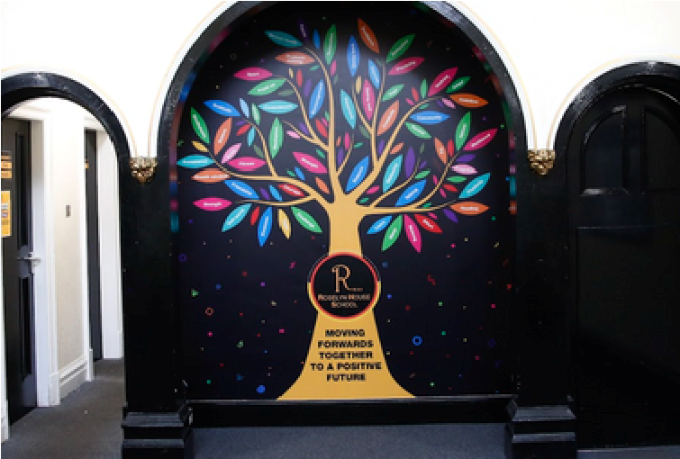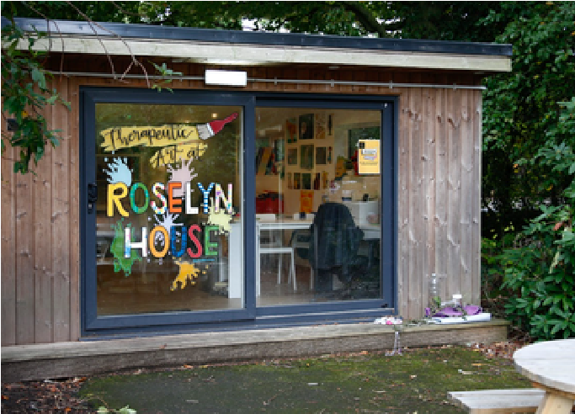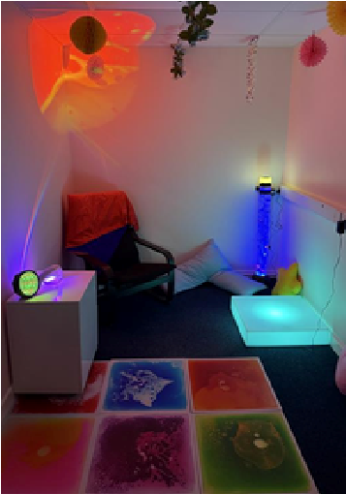
Summer Improvements Across the School
Over the summer break, a range of exciting improvements were completed
across the school to enhance our learning environment and facilities. A new car
park was constructed, providing safer and more efficient access for staff,
students and visitors. In addition, vibrant new school graphics have been
installed around the building, helping to create a welcoming and inspiring
atmosphere for everyone, alongside the completion of our two new sensory
spaces.

Events Calendar
The RHS Autumn Term 1 calendar has been packed with meaningful and successful events this term, showcasing the school ethos, engagement and shared love of learning...
Mental Health Day
To mark Mental Health Day, our school took part in the “Wear It Yellow” initiative to raise awareness about the importance of looking after our mental well-being. Students and staff came together by wearing yellow clothing and accessories. A bright and positive colour that symbolizes hope, happiness, and support for mental health. It was great day and everyone got involved.
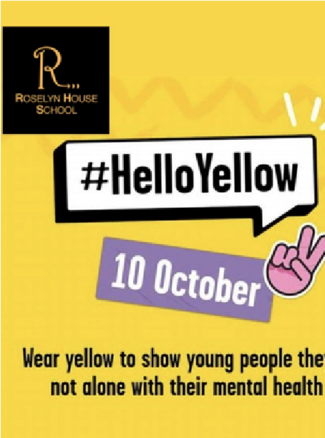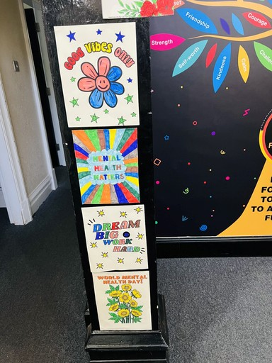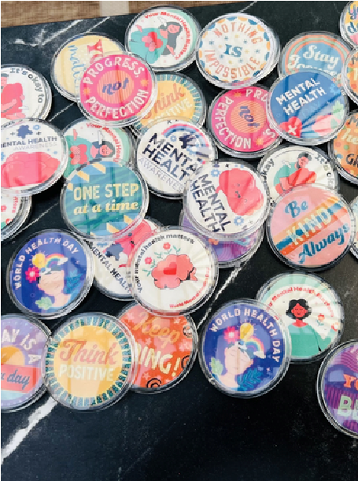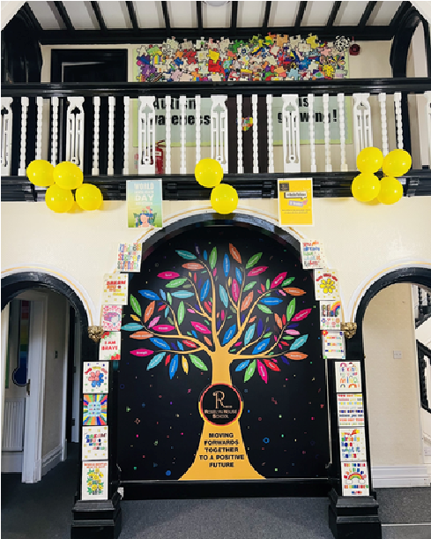
Remembering Hiroshima and Nagasaki: A Cross-Curricular Display
In History, students explored the events leading up to the atomic bombings and their lasting global impact, while in English they gave voice to those affected through powerful poems, diary entries, and survivorinspired writing. In Math's, they examined the scale of destruction by analysing data on blast zones, casualties, and long-term effects. In Art, students drew inspiration from the story of Sadako Sasaki, a young girl who folded paper cranes while battling radiation-induced illness, creating artwork that symbolises her hope, resilience, and wish for peace. Together, their work honors the memory of those affected and encourages us to reflect deeply on the human cost of war and the enduring need for peace.
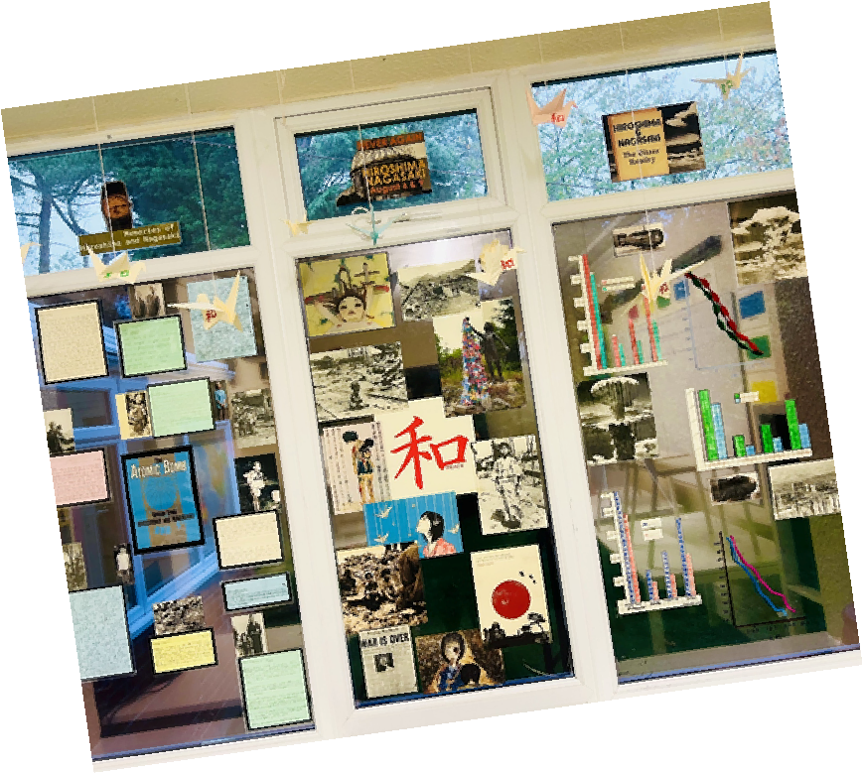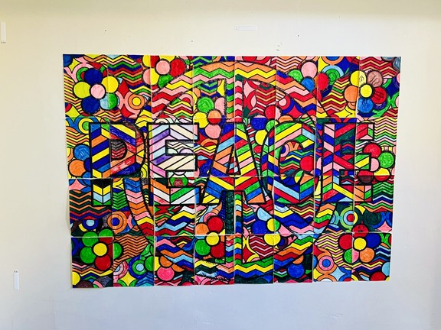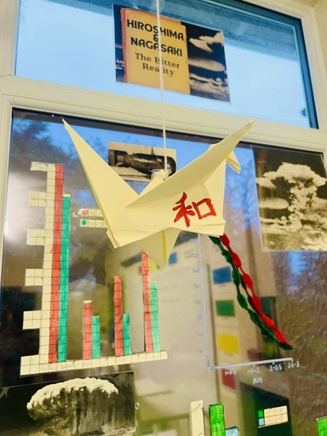
Student display work
We also celebrated National Libraries Week by welcoming a visiting author into school, and Diwali, in which students joined in the festivities....

Outstanding Achievements
Our Outstanding Achievement Awards celebrate the incredible efforts, creativity and accomplishments of our students each half term. Staff are invited to nominate students for recognition, whether it’s for exceptional work, a notable contribution in class or simply going above and beyond. Winners are carefully selected and receive a special award to honor their achievements, with presentations taking place at the end of the half term. These awards are our way of shining a spotlight on the talent, dedication and positivity within our school community.
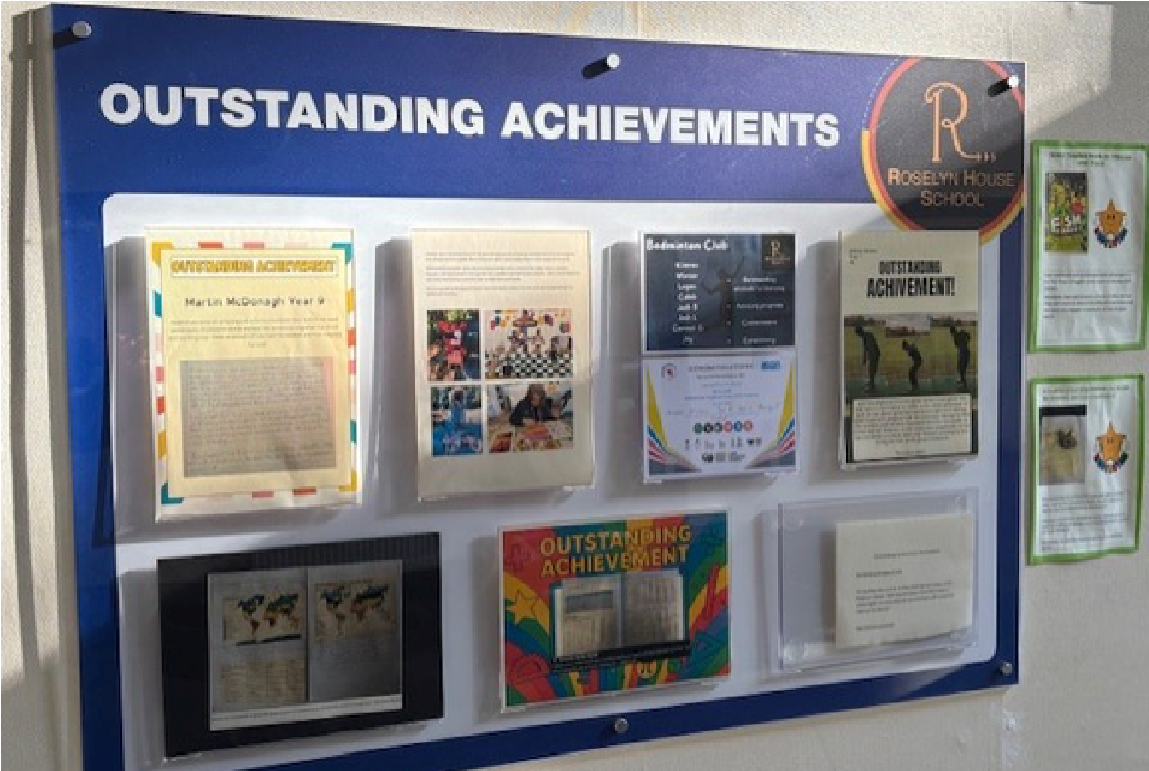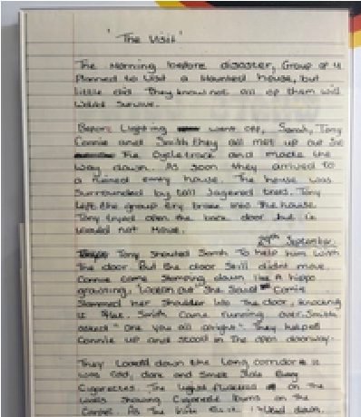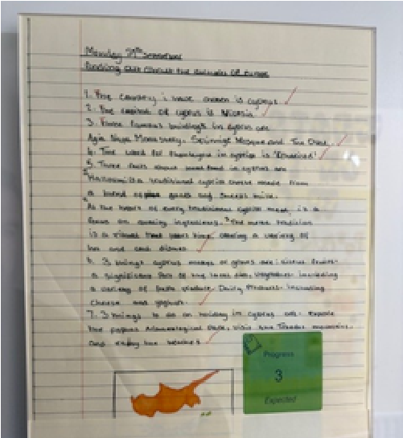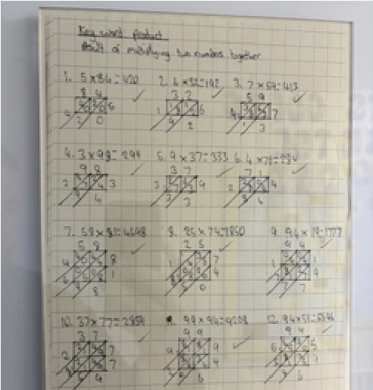
Yr 13 Maths

Yr 11 Creative Writing

Yr 11 Citizenship
KS3 nominations

This half term saw some truly remarkable
nominations, and all our students should be
incredibly proud of their efforts.

Looking Ahead to Autumn Term 2
Firstly, a huge thank you to our students, parents and staff for all their hard work and dedication this term. Your energy, enthusiasm and support make our school community so special.
As we move into Autumn Term 2, there is plenty to look forward to. Our calendar will include:
Anti-Bullying Week, where we will promote kindness, respect and inclusion across the school. National Recycling Week, encouraging students to think creatively about sustainability and the impact we all have on the environment.
Remembrance Day, a time to reflect and honor those who have served and sacrificed. St Andrew’s Day, celebrating Scottish heritage and culture.
We will also be launching our yearly “Delivering Joy” scheme, a special initiative where we give back to the local community and support those most in need in the lead-up to Christmas. In addition, a variety of exciting activities and events are planned to inspire, engage and celebrate our students. We’re looking forward to making the next half term another truly memorable one.
Have a wonderful half term break.

