Whole School Literacy
Roselyn House School
2025 – 2026


Approved by: | Jack Birkenhead | Date: 01/07/2025
Last reviewed on: | July 2025
Next review due by: | July 2026

- Introduction
At Roselyn House School, we are committed to developing the literacy skills of all of our students. Literacy skills are central to the development of learning, personal and social development and lifelong learning. This gives students the opportunity to contribute to the development of a successful life, where they can appreciate, enjoy, understand, evaluate, discuss and make informed choices and decisions.
We can find that many of our students have significant gaps in literacy development due to individual SEND diagnosis, gaps in education and anxiety around learning. They can be reluctant to participate in Literacy activities and fear that they will not be able to achieve. This is why it is important to see Literacy as a whole school curriculum and not just specific to English lessons or individual interventions. We adopt a disciplinary literacy approach in school. It is our aim that each of our students will leave our school with at least functional literacy skills and for the most part to go on to achieve GCSE or above. They may have to take a variety of curriculum pathways to achieve this but it is something that we believe in strongly and it is our aim that our students receive consistent, frequent and effective teaching and learning of literacy that has an impact on learning. It is the responsibility of all staff to promote literacy skills throughout lessons and during therapeutic and vocation sessions.
We are members of The Skills Academy, Book Trust and The National Literacy Trust.
This Policy should be read in conjunction with The Assessment and Marking Policy, SEN Policy and Curriculum Policy.

What is the point of Literacy?
- The point of literacy is to promote the skills students need to access the whole school curriculum confidently and effectively and also prepare them to communicate and think critically in all aspects of their lives.
- The purpose of the policy is to reinforce the principles of literacy skills needed in all areas of the curriculum to enable students to appreciate that there is a common expectation of these skills in all lessons. The policy promotes a common approach across the school to ensure consistency between subjects and to avoid confusion due to conflicting methods.

Who is responsible for Literacy?
- All staff are teachers of literacy and have a responsibility to promote literacy in their work with students.

We are committed to:
- Securing high standards of literacy across the school through developing a whole school Literacy Policy which enables staff to access support and guidance.
- Ensuring that a consistent approach to literacy is adopted by all staff to reinforce the skills needed and keep student confusion to the minimum.
- Ensuring an effective cross-curricular approach and identifying opportunities; indicating and facilitating areas for collaboration.
- Assisting in the transfer of skills and understanding between all subjects.
- Ensuring that students are aware of what is expected of their literacy skills.
- Providing engaging and appropriate literacy materials for students to access.
- Supporting students in their development and praising on their efforts and achievements.
- Regularly assessing students’ literacy ability and providing interventions in order to bridge gaps.
- Be inclusive to all students regardless of ability in order for them to access the curriculum and have the same chances.
- Recognise factors which can impede learning for the short and longer terms.

Consistency in teaching literacy is achieved when:
- Literacy skills are taught consistently and systematically through and across the curriculum
- Expectations of standards of accuracy and presentation are similar in all classrooms
- Teachers are equipped to deal with literacy issues in their subject both generically and specifically
- The same strategies are used across the school: teaching the sequence required for writing for specific purposes; active reading strategies and planning speaking and listening for learning
- The literacy focuses in English, together with specific intervention programmes, is consolidated in other lessons.
- Teachers use the same terminology to describe language
- Teachers use data relevant to literacy (reading ages, previous NC levels or CGA equivalent) to inform planning for personalisation

At Roselyn House School we recognise the Ofsted framework 2022 and encourage reading in all aspects of the curriculum and students are encouraged to develop their language and vocabulary also. We want to provide the best for our students.
We work within Literacy Learning Objectives and aim towards students achieving the following outcomes:

Spelling and vocabulary
Students should be able to:
- Correctly spell the subject specific key words
- Understand the meaning of the subject specific key words
- Use subject specific key words in context in their writing
Reading
Students should be able to:
- Read and follow written instructions.
- Read to explore and to develop understanding.
- Sift, select and take notes from the text.
- Access relevant textbooks, including format and index.
- Select from written material, reformulate, question and challenge what they read in textbooks, encyclopaedias, and newspapers or from ICT sources.
- Read for fun and select reading materials for their own enjoyment.
Writing
Students should be able to:
- Use writing to plan and organise.
- Plan, draft, discuss and reflect on their writing, using ICT, where appropriate.
- Write for a range of purposes and audiences.
- Make notes in a variety of formats, e.g. brainstorming.
- Write about the subject using different ways of opening, developing, linking and completing paragraphs.
- Use a variety of sentence structures.
- Write about their own life experiences/ emotions and creatively.
- Feel confident about sharing their writing with others; regardless of ‘mistakes’.
Speaking and Listening
Students should be able to:
- Listen and carry out instructions.
- Explore and develop ideas with others, through their talk.
- Ask questions as well as answer them.
- Work collaboratively with others.
- Speak confidently and fluently in discussions and debate.
- Speak about their own emotions and lives/ interests.
- Listen confidently and fluently in discussions and debate.
- Listen empathetically to others about their emotions and their lives/ interests.

- Literacy across the curriculum
Literacy underpins a student’s ability to access all areas of the curriculum and express their knowledge and understanding
All lessons include and largely depend on oral and written communication. The teacher explains, questions, describes, organises and evaluates in the classroom and does this mostly through talk, and sometimes through writing. Students often answer, discuss and work out their ideas through talk. They commonly write in order to record, summarise, note, show evidence of understanding and develop analyses and arguments. Successful learners read to gain access to and evaluate information and ideas from a range of texts and sources. It is therefore the responsibility of all teachers to support and contribute the development of literacy skills. It is important that we work together to ensure we equip students with basic life skills in literacy and identify opportunities for cross-curricular and literacy development.
Collaboration between English specialists within school with other subject areas can have different purposes:
- Collaboration can help to raise standards in ALL subjects.
- Literacy can support the work of other subjects.
- Other subjects can provide a context for Literacy.
- Collaboration can help students make connections

- Disciplinary/ Subject specific Literacy
Disciplinary literacy – also known as academic or subject-specific literacy – is a crucial consideration when approaching teaching subject-specific vocabulary, critical thinking, subject knowledge and skills within a subject.

It enables students to read, write, speak about, listen to and think conceptually and critically as experts in a certain subject.

In short, teaching disciplinary literacy is asking students to ‘think, speak, read and write as a historian, scientist, or mathematician’, as Alex Quigley describes in Closing the Vocabulary Gap.
Disciplinary literacy is fundamental to developing the strong literacy skills that are vital to success at school and beyond.

So much so that “prioritise ‘disciplinary literacy’ across the curriculum” is the first recommendation in The Education Endowment Foundation’s Improving Literacy in Secondary Schools guidance report.

The report notes that literacy is ‘a strong predictor of outcomes in later life.’ The EEF clarifies further:

‘Literacy in secondary school …. must be grounded in the specifics of each subject. In particular, the report emphasises the importance of ‘disciplinary literacy’, an approach to improving literacy across the curriculum. It recognises that literacy skills are both general and subject specific, underlining the value of supporting teachers in every subject to teach students how to read, write and communicate effectively in their subjects.’

At Roselyn House School, key vocabulary, key terms, Literacy focus and Language for learning are included within schemes of work and planning. Students are introduced to new subject specific vocabulary through Literacy focus displays in school, checklists, challenges and homework tasks.

These are some examples of how disciplinary literacy can be applied to subject areas across the curriculum in order to boost students’ understanding of language and concepts that are most relevant to that area.

Science
- Understanding the difference between correlation and causation
- Questioning if research is biased
- Asking if results support the conclusions

Maths
- Estimating the answer and being able to explain why
- Calculating the probability of something happening
- Drawing conclusions from materials such as graphs and diagrams

Humanities

- Asking if a source is primary or secondary
- Questioning the impact of humanity on our environment
- Suggesting a reason for a change between places or over time

Arts
- Exploring texture, colour palette and technique
- Identifying genre
- Considering the effects of crescendos or tempo changes in a piece of music

Disciplinary literacy helps students to understand and communicate using specialist vocabulary and concepts. They become more confident and this leads to higher expectations of themselves. It may also encourage a passion for the subject and unlock a passion for a particular field of study and also empower students towards self-directed/ independent study.

As a result of this, students are able to access and critique more complex learning which further enhances their experience. The disciplinary approach enables students to transfer their learning to the real- world.

It is the aim of Roselyn House School to embed disciplinary literacy into the basis of lesson practice which continues to improve student understanding, engagement and outcomes in all aspects of the curriculum and to make the learning of new vocabulary/ key terms, exciting and fun.

We will provide whole school INSET, support for staff on Disciplinary Literacy and short reminders. Eg.

- Literacy Across the Curriculum:
https://www.youtube.com/watch?v=R088edAQYzc
- Teaching Literacy Across the Curriculum:
https://www.youtube.com/watch?v=Uww66wi517Y

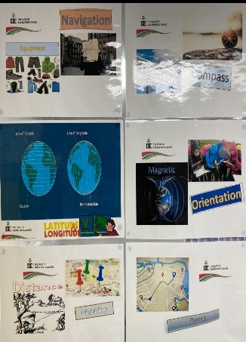
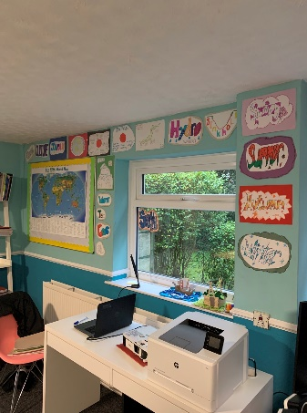

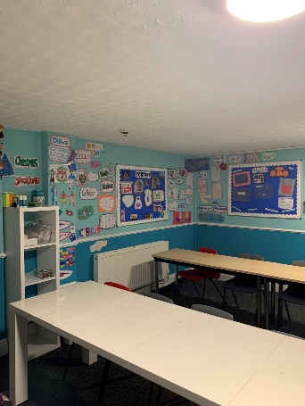

- Roselyn House School development in Literacy

Each student has access to work one-on-one or in small groups with Mrs Wilson (SENCO) and various learning support assistants, who are offering a variety of sessions in reading, literacy, numeracy, grammar and punctuation, as well as emotional and behavioural management. Each session is structured to aim towards the targets of the students.

Several students will participate in reading aloud while debating the themes and ideas of the entire chapter. Many fiction and nonfiction books from the school library are great for this, with students engaged and excited to pick out what they shall be reading next. Several students have used accelerated reader to learn to read when struggling with pronunciation and understanding the text. These have been very useful for printing to highlight and create activities around exploring words in the text.

Students participate in writing informative pieces, personal narratives, and persuasive texts. Several students are currently writing book reviews while strengthening their sentence structure and text retention skills, with a high success rate of students happy to engage due to having enjoyed the book. We focus on phonics, comprehension exercises, and boosting their confidence. Some students will come in to have one-to-one sessions with work set that they are struggling to complete or focus on. Students have the send resources available during sessions.

Every individual and group session are written up, explaining what went well, what can be looked at and cross reference with the SENCO for guidance if necessary. We also cross-reference with teaching staff and form teachers, whether this be additional needs, support in certain areas, or to simply showcase work created that the individual is proud of.

There is an increase of books, magazines and e-books in the school Library.

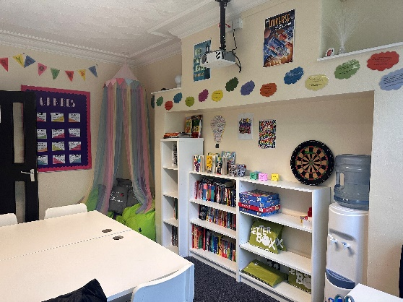
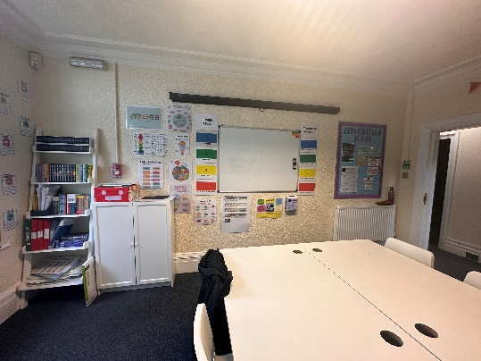

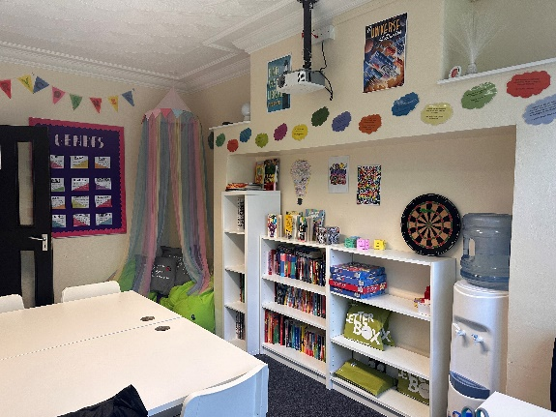

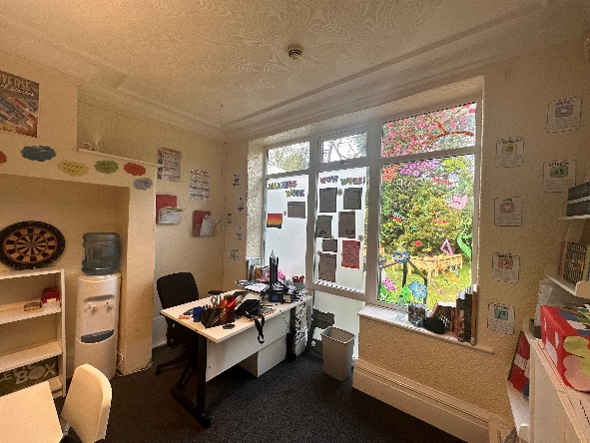

Our Year 7 students are involved in the Letterbox Club Programme from May- October. These parcel sets are targeted at the student’s literacy ability and age. The scheme is aimed at vulnerable young people, students in care or recently left. They are personalised for each of our students and are given out where they can complete activities, within the school library or at home. Each of the pack contents is for the student to keep. The students will receive a total of 14 books, 10 Maths games and around 40 items of quality stationery. The aim is to inspire a love of reading and engagement with numeracy. This scheme provides support over the Summer Holidays as well as supporting transition into the next school year. We currently use green and red sets.

Key findings from 2021-2022 Letterbox evaluation state:

‘Children report high levels of usage of Letterbox Club parcels, with 92% of children using their parcels and 50% using them ‘a lot’. Children also tell us they keep their parcels and continue to use them over time, demonstrating the lasting value of Letterbox Club resources.’

‘Our evaluation indicates that Letterbox Club has a positive impact on children’s reading habits. Children report that parcels support their confidence in reading and enjoyment of books. 66% of children say they read more on their own since receiving Letterbox Club parcels.’

‘Foster carers tell us that Letterbox Club provides children with a greater choice of reading materials, which can expand their interests. Carers value having someone outside of the home and school environments to encourage their children to read.’

‘Children also tell us that Letterbox Club supports their wellbeing. We heard that Letterbox Club positively impacts on some children’s imagination and creativity and encourages feelings of calm. Importantly, Letterbox Club also makes children feel important and held in mind.’

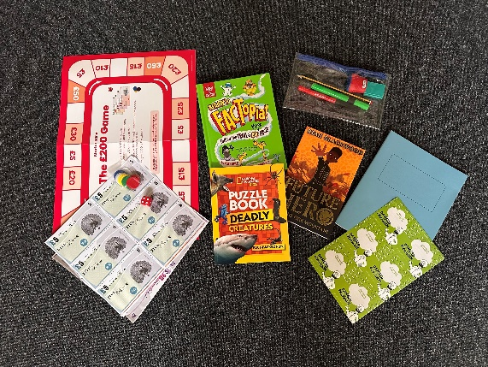

Students in Key Stage 3 also have access to Bookbuzz, a reading programme to help further inspire the love of reading. Students have the opportunity to choose their own book to take home and keep from a list of 16 titles. These are all carefully selected by a panel of experts to ensure suitability and to encourage reading for pleasure.

www.booktrust.org.uk/what-we-do/programmes-and-campaigns/bookbuzz/

Each year we participate in World Book Day where students are able to pick up their book vouchers. We hold copies of £1 books in the library.

www.worldbookday.com

- RHS KS4/5 development in Literacy

There are specific Literacy interventions in place for students with Mrs Wilson (SENCO) and she also advises staff on specific strategies which would be useful to support students.
There is a designated Library space at the back of the English Classroom and a chill out zone where students are encouraged to pick up reading materials for fun and relaxation. There has been an increase in age appropriate and young adult themed literature which has been selected by students themselves. Students borrow books to take home and read and then return.

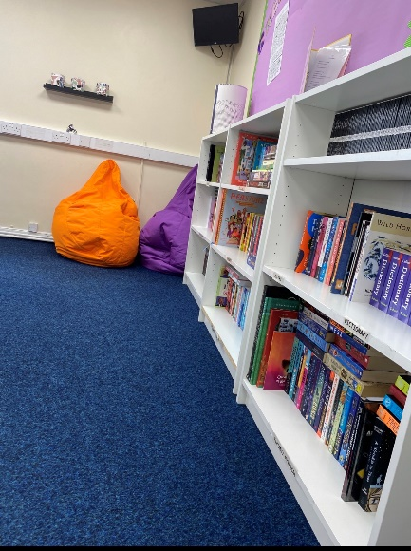

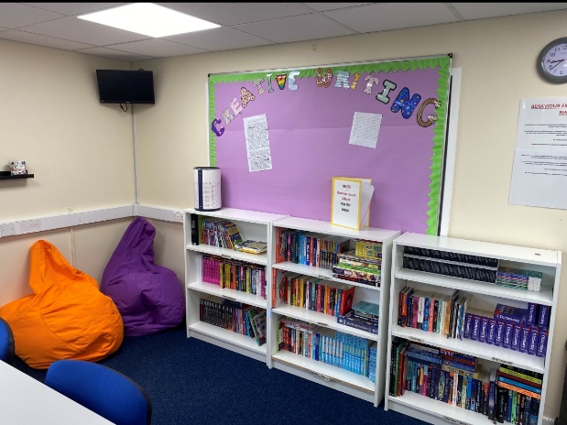

As part of student council, a poetry folder has been set up for KS4/5 students to contribute their original poems. These are published on the school website and the aim is that at the end of the school year these will be put together in a poetry book which can be used by younger students in Literacy sessions from September onwards. This is helping our older students KS4 and KS5 to not only develop their own writing and expression skills but also to inspire young people with their work and what you are able to achieve.

Through Adulthood Pathway, students use everyday literacy to develop their life skills and ability to perform day to day tasks required to develop independence in society.

Various projects taken in RHS etc (enterprise training curriculum) involve recording information, setting out business plans, projections and marketing strategies which help to develop with literacy skills, in particular the £20 challenge which sees students grow a business idea from the initial set up cost.

Drama workshops take place which have English Literature and PSHE based themes which help to develop speaking and listening, expression and whilst helping students take part in Teamwork and grow in confidence.

- Focus Weeks/ Days

Across the school year we have on average 3 focus days per month. These can be found in the monthly news letter. Resources are used which encourage the use of literacy across the topic area. Resources can be found on the shared drive.

Responsibilities of Teaching staff
- To ensure that 'subject specific literacy'/ disciplinary literacy is clearly identified in schemes of work, and that there is obvious progression through the key stages
- To ensure that they are familiar with the specific literacy demands of their subject and plan to cover these skills in their lessons
- To know the reading writing ability/level of each student in their class, the characteristics of their reading/writing ability and be aware of appropriate expectations of students and difficulties that they might experience, this is identified in Learning Support Plans
- To teach students the necessary skills required for extended writing in their subject area e.g. explanation, informing, instruction
- To display Word of The Week in the classroom/ website and encourage students to participate
- To have a literacy focus board in school
- To ensure students know the meanings of the key words in that subject area
- To use the agreed strategies in order to teach Writing, Speaking, Listening and Reading skills
- To follow the whole school Marking Policy when marking spelling, punctuation and grammar by highlighting 3 spelling and 3 Grammar/ Punctuation mistakes
- To understand that little and often correction is more suitable for our students and not to write all over their work as pointing out lots of mistakes will only affect confidence and the ability to progress
- To ensure they are aware of the reading and writing characteristics of their students
- To level work in accordance with RHS levels

Responsibility of Headteacher, SENCO and Year Leads To train staff on how to develop the relevant writing skills necessary for their subject area/provide appropriate training
- To use reading age and English NC levels/CGA equivalent/GCSE grade data to inform setting and intervention
- To monitor use of whole school Assessment and Marking Policy when conducting work scrutiny
- To monitor and evaluate the progress of students supported by intervention programmes, and modify or abandon those which are not showing successful impact
- To track reading ages of all students
- To use data, including periodic assessment – for example Assessing Pupils' Progress (APP, ISV etc.) – to track the progress of all students, and to identify individuals and groups of children who are not making sufficient progress
- To enable learners to progress beyond the norms expected for their year group where appropriate.
- To provide appropriate training for developing extended writing and active reading strategies
- To monitor reading habits of all students
- To update Learning Support Plans with skills specific information linked to Reading and Writing.
- To provide tailored training on raising literacy levels for specific groups.
- To monitor all students with a reading age of 10 y. or below.

- Reading Strategies

- Encourage reading for pleasure.
- Have quiet reading areas/ small libraries set up around school
- Offer a range of reading materials including short reads, magazines and vocational specific texts/ areas of interest
- Develop a reading display wall of books that students or staff are currently reading and update on a regular basis
- Nominate a ‘best book’ of a Half Term to encourage reading it
- Staff read alongside students and also model reading
- Group reading, reading aloud, use of e-books
- Provide individual intervention Accelerated Reading Scheme, physical and digital books with appropriate levels based on assessment from SENCO
- Encouragement to read in all subjects
- Have follow up tasks to ensure students have read where they may spend time talking to a partner about the text and making sure they understand what they have read
- Students could be asked to represent what they have read in a picture or diagram
- Teachers could provide information from a specific text in the incorrect order and students have to re-arrange to the correct order
- Write 3 relevant questions they would like to answer before reading a text
- Provide a list of challenging words which will be used in the text and find the meaning
- Play games to develop understanding of subject specific and general vocabulary
- Play games like odd ones out and provide a list of 4 key terms so the student has to find the odd one out
- Make key words integral to lesson and reinforce through spellings, use and definitions. One student could spell the word, one define it and one use it in a sentence.
- Teach the skills of skimming, scanning and close reading
- Provide display books
- Encourage reading around the subject and set for homework
- Provide subject specific reading lists
- Record reading daily on Teacher tracking digital proforma
- Record individual reading interventions via Accelerated reading tracker sheet

Writing strategies

- Encourage students to keep a writing journal where they write creatively. It could be about a given topic or related to something they do. Encourage writing for pleasure or putting down emotions.
- Use the word of the week to develop vocabulary and test the commonly misspelt words.
- Set spelling tests and see that it is not something just done in English lessons.
- Spelling displays can be set up in classrooms.
- Identify errors in students writing using the Literacy Marking Policy.
- Address spelling in the following lesson. Make it clear to students where they may be going wrong with spellings.
- When teaching complex new vocabulary, help students to develop strategies for remembering the terms and spellings, such as mnemonics
- Teach students the strategies for spelling such as look, cover, spell, heck; exploring the root word; sounding out syllables etc.
- Regular spelling tests
- Specific subject glossary
- Writing has different forms, purposes, rules and features. Encourage students to identify the purpose and form before they begin to write. Discuss rules and features with staff and peers to have a clear understanding of what they do.
- Teachers demonstrate examples of mediocre and excellent pieces of writing to see what they need to do to improve their skills.
- Discuss ideas with a partner before they write. This can be useful part of the planning process.
- Use mini whiteboards, A3 paper etc.
- Teach students to plan don’t assume they know.
- Model by writing at the same time as students.
- Use connectives in talk to encourage their use in writing.
- Talk about the use of paragraphs, connectives and complex sentences.
- Reinforce the word of the week to extend students’ vocabulary.
Speaking and Listening strategies
- Encourage students to give presentations.
- Discuss what makes a formal presentation effective.
- Give students clear success criteria.
- Make students aware of the need to speak formally.
- Encourage students to respond in full sentences both verbally and in writing.
- Encourage students to be active listeners.
- Use plenaries, for example, as a chance for students to ask and respond to questions.
- Use podcasting and videoing to encourage spoke communication.
- Use starters as opportunities to encourage speaking skills.
- The Teacher could sit in a different student’s seat at the start of a lesson and the student has to deliver the starter.
- Boost effective discussion skills by teaching students what makes an effective discussion and what the aims of their discussion are before putting them in groups to discuss ideas.
- Promote debates in lesson.
- Allow students to prepare starters.

SEND Accessibility resources to support Literacy
- Each classroom contains a SEND resource box which should contain the following items:
- Small white boards
- Pencil grip pens
- Fingerless gloves
- Coloured overlay
- Slopping writing boards
- Thick triangular pens and pencils
- Thin triangular pens and pencils
- There is a list of resources which individual students may choose to use on the staff SharePoint and Mrs Wilson is available to discuss specific needs. There is also an increased access to student laptops and each site has an exam reader pen available through a booking out system.

Specific Literacy Marking Code
Following on from our last Ofsted inspection in 2019, we, encourage students to write more regularly and consistently check students’ grammar, punctuation and spelling.
When marking a piece of work select 3 spelling mistakes and 3 Grammatical or Punction errors. (SPAG) Be mindful not to write all over a students work.
Use 2 stars and a wish and RHS Level at the end of the work.
If required to write further detail use a Post it note.
Use the following code for marking written work:

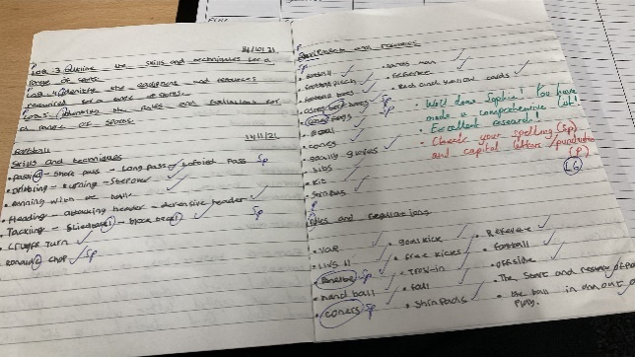
Sp… … … Incorrect spelling
^ … … … A word left out
P … … … Punctuation mistake
// … … … New paragraph
? … … … This part is confusing
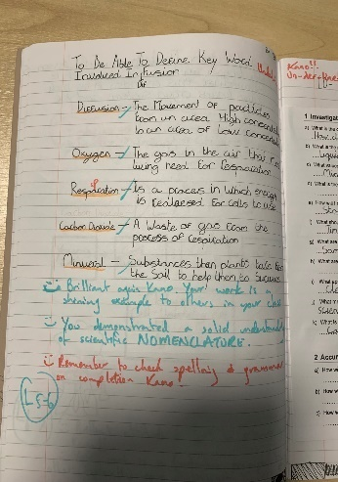
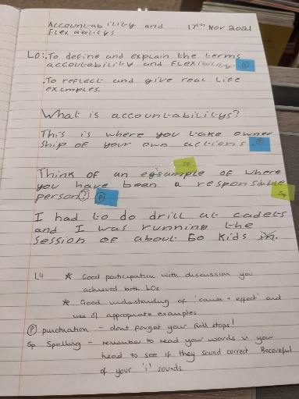

- Monitoring Arrangements
This document will be reviewed every year, but may be reviewed and updated more frequently if necessary. It will be reviewed by Mr Jack Birkenhead (Headteacher) in consultation with the wider school community.
- Linked Policies
This policy is linked to the following policies and documents:
- Curriculum policy
- Assessment and Marking policy

